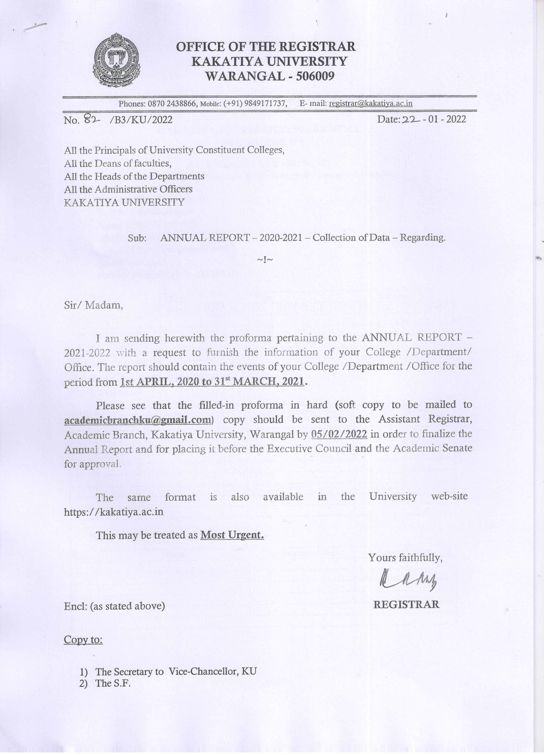
PROFORMA – C FOR UNIV. TEACHING DEPARTMENTS

KAKATIYA UNIVERSITY:: WARANGAL
ANNUAL REPORT

ACADEMIC YEAR -2020-2021
(Before filling up the format, please go through the instructions overleaf)

 | Name of the Department | :
 | Year of Establishment | :
 | Name of the Head with | :
 | Qualifications
 | Name of the Chairperson with | :
 | Qualifications
 | Faculty strength as on 31/03/2021 | :

Cadre | Total  (M+F) | Male |  |  |  |  | Female
Cadre | Total  (M+F) | OC | BC | SC | ST | Total | OC | BC | SC | ST | Total
Professors
Associate Professors
Assistant Professors
TOTAL

- Faculty Composition as on 31.03.2021

A) Professors

S.No. | Name | Qualifications/Univ. | Specialisation

B) Associate Professors

S.No. | Name | Qualifications/Univ. | Specialisation

C) Assistant Professors

S.No. | Name | Qualifications/Univ. | Specialisation

- Students Enrolment : No. of students admitted to Programmes

Courses offered | Total  (M+F) | Male |  |  |  |  | Female
Courses offered | Total  (M+F) | OC | BC | SC | ST | Total | OC | BC | SC | ST | Total
PG
M.Phil
Ph.D.
Any Other

- Degrees & Diplomas awarded : Research Degrees

Course | Sex | No. of candidates awarded
Course | Sex | OC | BC | SC | ST | Total
PG | M
PG | F
M.Phil | M
M.Phil | F
Ph. D. | M
Ph. D. | F
Any Other | M
Any Other | F

- Details of the courses for which the syllabus was revised

S. No. | Name of the Course

- Research Activities of the Department

Sl. No. | Name of the Supervisor | No. of students currently working
Sl. No. | Name of the Supervisor | Within the University | Outside the University

- Books/Research Publications in International/National Journals

Name of the Teacher | Title of the Books /Article | Details of Publication

- Seminars/Conferences/Work-shops etc. organised

Name of the Seminar/ Conference/Work-shop | Date | No. of papers presented | No. of participants |  | Source of funding
Name of the Seminar/ Conference/Work-shop | Date | No. of papers presented | KU | Other Institutions | Source of funding

- Faculty participation in Seminars/Conferences/Workshops etc.

Name of the Teacher | Seminar /Conf./  Work-shop attended | National / International | Duration |  | Venue
Name of the Teacher | Seminar /Conf./  Work-shop attended | National / International | From | To | Venue

- Research Projects ongoing/completed

Name of the Investigator | Title of the Project | Duration | Funding Agency

- Awards/Honours conferred

Name of the Teacher | Award/Honour

- Students’ achievements

Name of the student | Achievement/Award/Honour

- Visits on Academic Assignments

Name of the Teacher | Place | Purpose | Duration

- Visitors of National and International repute to the Department

Name of the Visitor | Country | Institution | Purpose of visit

- Extension Programmes: (Including TV/AIR Programmes)

Name of the Teacher | Nature of Interaction | Place of Interaction | Duration

- Popular Lectures by Faculty

Name of the Teacher | Subject/theme | Institutions where the lecture is delivered

- Organisation of Exhibitions/Programmes of Public interest

Name of the Teacher | Subject/theme | Name of the Exhibition/Programme

- No. of Research Design Seminars/Pre-Submission Seminars presented

Research Design Seminars | Pre-Submission Seminars | Total

- Cultural activities/Excursions/Visits to Industry/Field/Institutions:

S.No. | Place | Name of Institution visited

24. | New buildings/Modernisation of Labs/Seminars Halls etc. and efforts made For beautification of the campus in terms of Developing greenery and maintaining cleanliness | :
25. | No. of Departmental Research  Committees meetings held on | :
26. | Milestones in the History of the  Department from the inception in  Chronology order | :
27. | Significant events of the Year | :
28. | Future Projections/Plans of the Department
29. | Any other important information | :

Date: Signature of the Head & Seal

INSTRUCTIONS

- The information called for is pertaining to the academic year 2020- 2021 i.e. from 1st April 2020 to 31st March 2021. The data prescribed in the format along with soft copy (C.D enclosed) should be sent to the Office of the Assistant Registrar, Academic Branch, KU, well before05/02/2022, failing which, the data pertaining to that particular College will not be included in the Annual Report and the matter would be intimated to the Executive Council and the Academic Senate, accordingly.

- If the format is not sufficient for filling any information, please get it typed on a separate full-scape size paper (in the prescribed format).

- The Abbreviations used are: T- Total; M- Male; F- Female; SC- Scheduled Caste; ST- Scheduled Tribes; BC-Backward Classes; OC-Other Castes; TM – Telugu Medium; EM- English Medium.

